Problem 1:
Write a program that pushes two 16-bit values onto the stack, calls a procedure that retrieves them using a stack frame (BP), adds them, and returns the sum in AX. Display the operands and the result in hexadecimal.

Codes:
.model small
.stack 100h
.data
op1 dw 1234h
op2 dw 5678h
l1 db 'A: $'
l2 db 'B: $'
l3 db 'SUM: $'
nl db 13,10,'$'
.code
main proc
mov ax, @data
mov ds, ax
lea dx, l1
mov ah, 09h
int 21h
mov ax, op1
call printhex
lea dx, nl
mov ah, 09h
int 21h
lea dx, l2
mov ah, 09h
int 21h
mov ax, op2
call printhex
lea dx, nl
mov ah, 09h
int 21h
push op2
push op1
call add_vals
add sp, 4
lea dx, l3
mov ah, 09h
int 21h
call printhex
lea dx, nl
mov ah, 09h
int 21h
mov ah, 4Ch
int 21h
main endp
add_vals proc
push bp
mov bp, sp
mov ax, [bp+4]
add ax, [bp+6]
pop bp
ret
add_vals endp
printhex proc
push ax
push bx
push cx
push dx
mov cl, 4
mov ch, 4
hl:
rol ax, cl
mov bl, al
and bl, 0Fh
cmp bl, 9
jbe d1
add bl, 7
d1:
add bl, 30h
mov dl, bl
mov ah, 02h
int 21h
dec ch
jnz hl
pop dx
pop cx
pop bx
pop ax
ret
printhex endp
end main

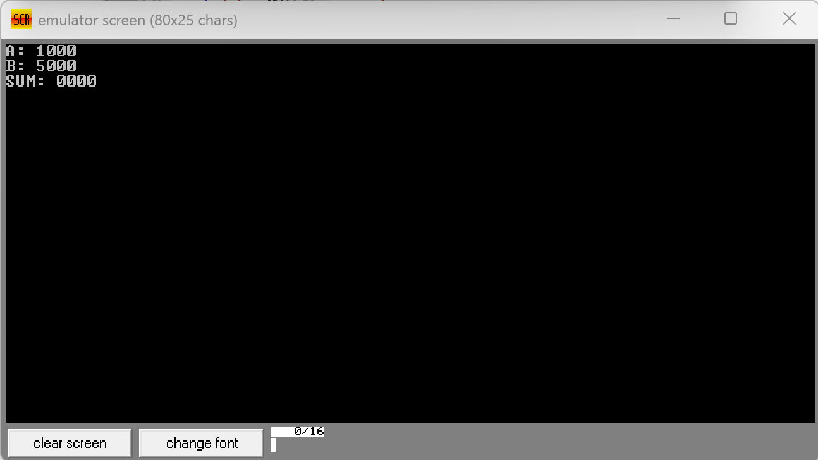
Output:
Problem 2:
Write a program that multiplies two 16-bit unsigned numbers (0010h and 0008h) using the MUL instruction. Display the resulting 32-bit product (stored in DX:AX) in hexadecimal.

Codes:
.model small
.stack 100h
.data
mul1 dw 0010h
mul2 dw 0008h
l1 db 'RESULT(DX:AX): $'
nl db 13,10,'$'
.code
main proc
mov ax, @data
mov ds, ax
mov ax, mul1
mov bx, mul2
mul bx
lea dx, l1
mov ah, 09h
int 21h
push ax
mov ax, dx
call printhex
pop ax
call printhex
lea dx, nl
mov ah, 09h
int 21h
mov ah, 4Ch
int 21h
main endp
printhex proc
push ax
push bx
push cx
push dx
mov cl, 4
mov ch, 4
hl:
rol ax, cl
mov bl, al
and bl, 0Fh
cmp bl, 9
jbe d1
add bl, 7
d1:
add bl, 30h
mov dl, bl
mov ah, 02h
int 21h
dec ch
jnz hl
pop dx
pop cx
pop bx
pop ax
ret
printhex endp
end main

Output:
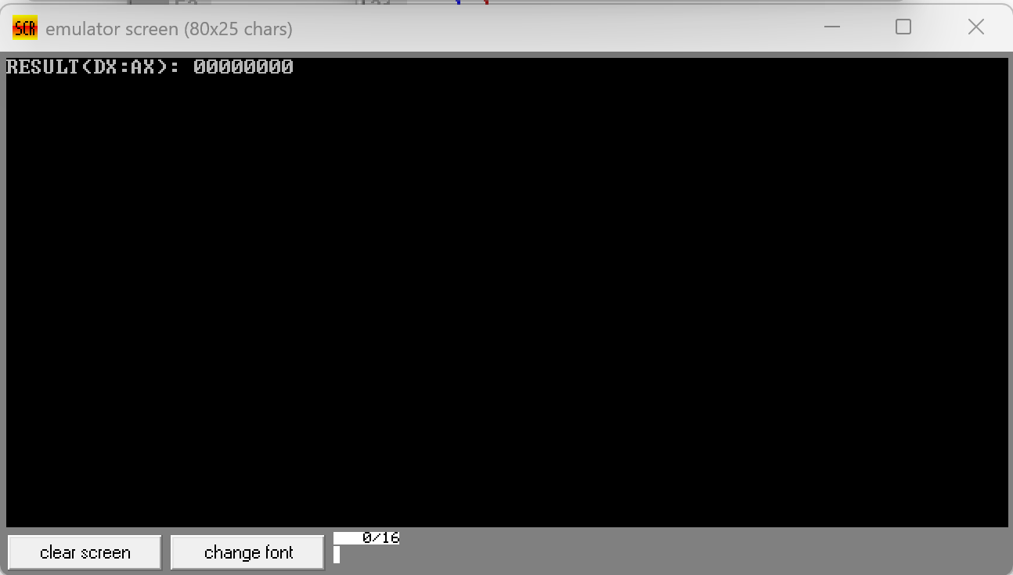

Problem 3:
Write a program that divides a 32-bit unsigned dividend (00000014h in DX:AX) by a 16-bit divisor (0004h) using the DIV instruction. Display the 16-bit quotient (AX) and 16-bit remainder (DX) in hexadecimal.

Codes:
.model small
.stack 100h
.data
dividend_lo dw 0014h
dividend_hi dw 0000h
divisor dw 0004h
l1 db 'QUOTIENT: $'
l2 db 'REMAINDER:$'
nl db 13,10,'$'
.code
main proc
mov ax, @data
mov ds, ax
mov ax, dividend_lo
mov dx, dividend_hi
mov bx, divisor
div bx
lea dx, l1
mov ah, 09h
int 21h
call printhex
lea dx, nl
mov ah, 09h
int 21h
lea dx, l2
mov ah, 09h
int 21h
mov ax, dx
call printhex
lea dx, nl
mov ah, 09h
int 21h
mov ah, 4Ch
int 21h
main endp
printhex proc
push ax
push bx
push cx
push dx
mov cl, 4
mov ch, 4
hl:
rol ax, cl
mov bl, al
and bl, 0Fh
cmp bl, 9
jbe d1
add bl, 7
d1:
add bl, 30h
mov dl, bl
mov ah, 02h
int 21h
dec ch
jnz hl
pop dx
pop cx
pop bx
pop ax
ret
printhex endp
end main

Output:
